Journal About Being An Officer Or On A Committee
Officer
- Select Enter your FFA offices
- Select Add New Office
- Select the Office you currently hold, the level is most likely chapter, beginning date is banquet, and ending date is next years banquet (sometime in May - we can change later) – Select Save Changes
- Select Journal
- Select Time in FFA office
- Select the date the activity actually occurred
  - Select/Type the name of the activity
    - Ex: officer/chapter meeting, local FFA activities that are run by the officer team
- For Type select your officer position
- For Level select if it was a chapter activity of something else (Most things about the chapter level will be put in another place
- In 1 - 4 sentences tell me what the activity was
  - Ex: We had out 1st officer meeting where we discussed the expectation of being an officer, state convention, and summer dates.
- Tell me how long it lasted
- Hit SAVE

Committee
- Select Enter you FFA committee memberships
- Select a Committee that you have signed up for or been assigned
  - See Committee Information document for more details
- Select the date you were assigned to the committee
- Select Add New
- Select Journal
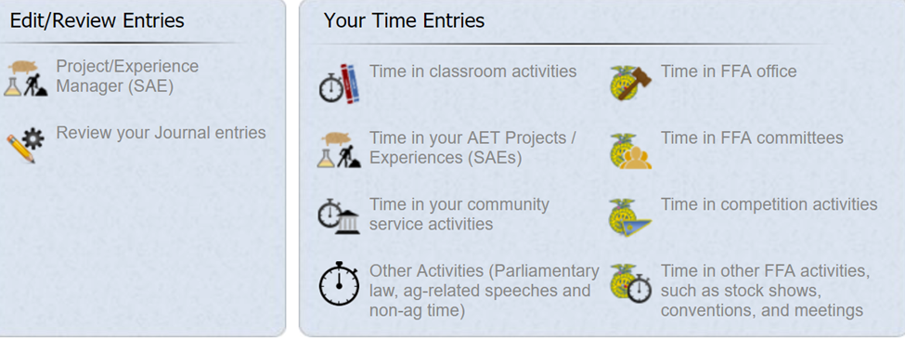
- Select Time in FFA Committees
- Select the date the activity actually occurred
  - Select/Type the name of the activity
    - Ex: committee meeting, Santa’s Farm, Santa’s Farm Set up
- For Type select your committee
- In 1 - 4 sentences tell me what you did
  - Ex: We had out 1st committee meeting where we discussed the expectation of for the event, divided up tasks, and set dates to meet again
- Tell me how long it lasted
- Hit SAVE

